UK & US

**Part I – The UK vs The US**

1. Spelling
2. Vocabulary

**Part II – The UK**

1. Introduction
2. Language
3. Values
4. Beliefs
5. Norms
6. Artefacts

**Part III – The US**

1. Introduction
2. Language
3. Values
4. Beliefs
5. Norms
6. Artefacts

The UK

1. INTRODUCTION

**SPEAKING PRACTICE**

What do you know about the United Kingdom?   
What are the most famous stereotypes about brits?   
Do you agree with the following pictures?

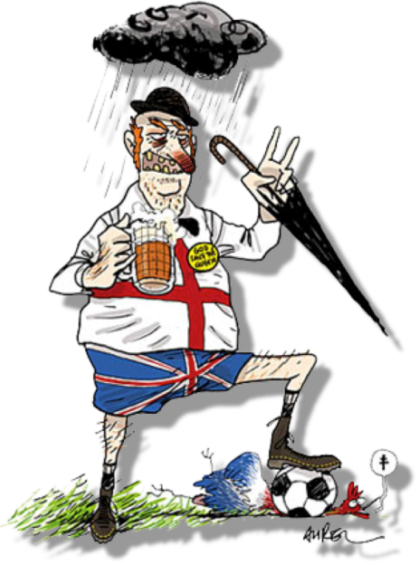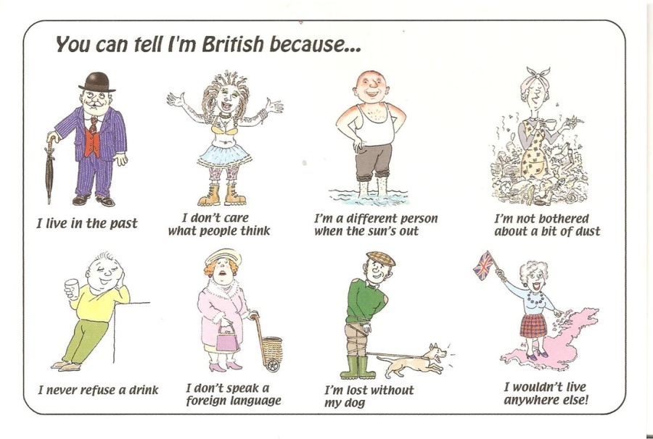

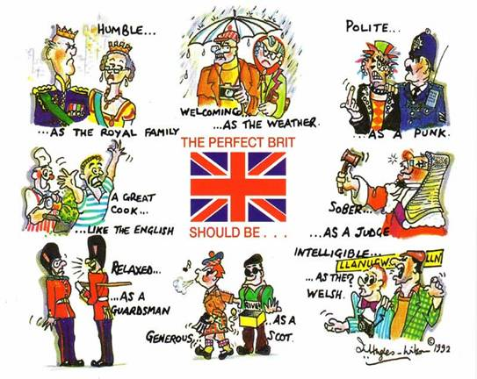

**WARMER**

1. How many countries are there in the United Kingdom? Can you name them?

4 : Englend (Angleterre), Scotland(Ecosse), Wales(Pays de Galles), Northern Ireland (Irelande du nord)

2. Is there a difference between Great Britain and the UK? Which one?

**Great Britain doesn’t count Notherne Ireland in**

3. Look at the map below. Write the names of the countries on the map.

4. Write the names of the capital cities on the map.

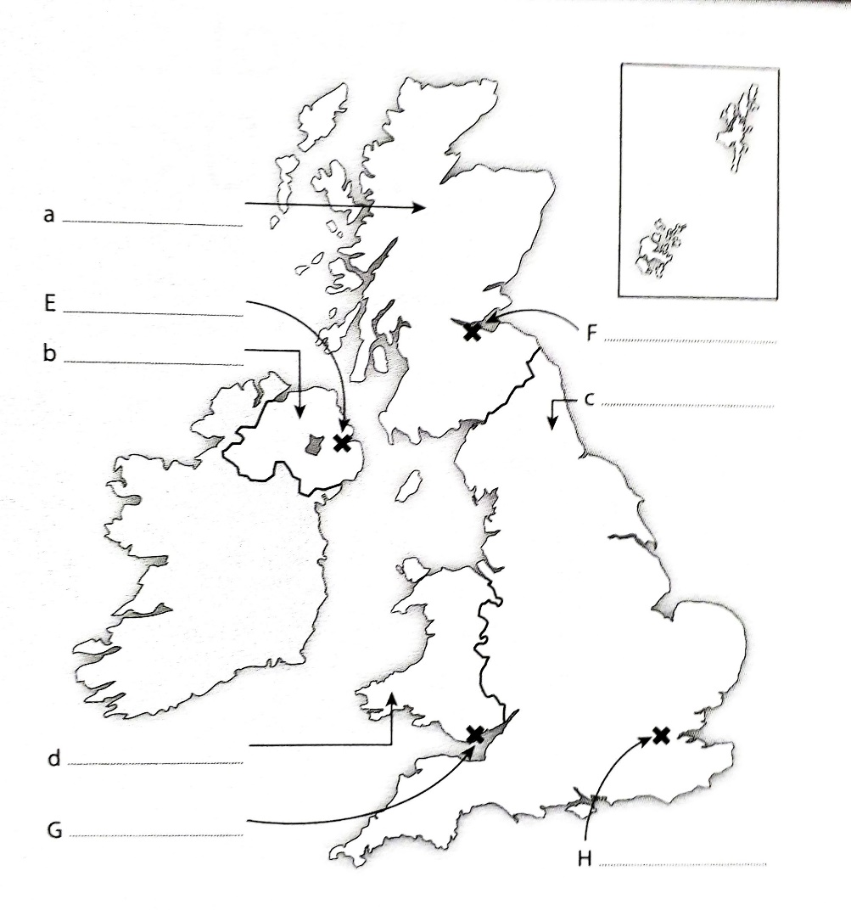

5. Locate the Republic of Ireland on the map. What is its capital city?

6. *Complete the following sentence* : The island of Ireland comprises ………………… ………….. , which is a sovereign state, and …………………………….. , which is part of the UK.

7. Locate the Shetland Islands on the map. What country do they belong to?

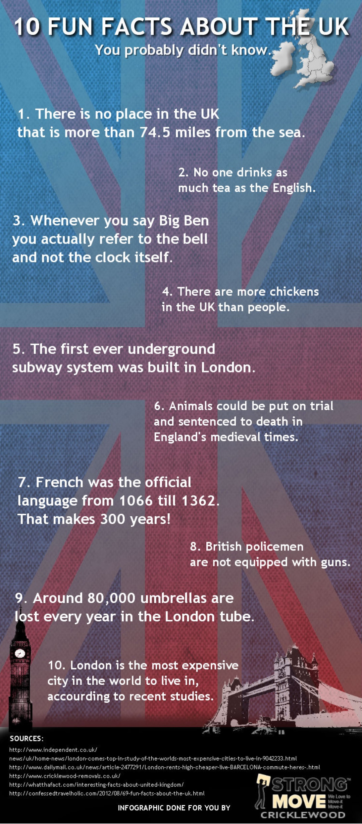

1. LANGUAGE

**LISTENING ACTIVITY**

<https://www.youtube.com/watch?time_continue=67&v=YEaSxhcns7Y&feature=emb_title>

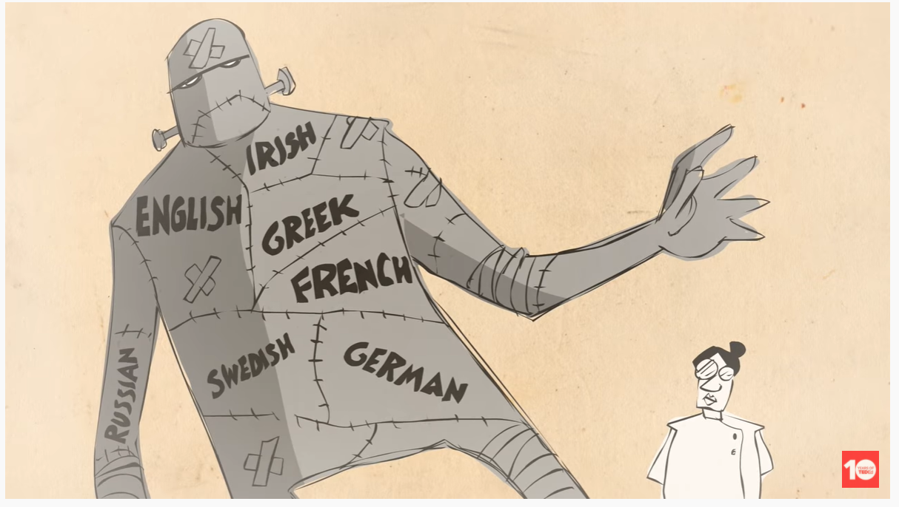

1. Who are Chaucer & Beowulf?
2. Fill in the gaps:

By undoing these changes, we can __________ the language from ______________________ back to _____________________________________

1. With which language does modern English share similar words?

1. Name an important event in the history of the English language.   
   What were the consequences?

1. In which language is Beowulf written? Where does this language come from?

1. Fill in the gaps

The ____________________ dialects they spoke _________ __________________ known as _______ _________________. ______________ ________________ in the 8th to 11th centuries added more __________________ from Old Norse ______________ ________

1. What is the origin of “skirt” & “skull”

1. What do German, English & Swedish have in common?

1. What is the Indo-European family?

1. What are examples of English’s distant relatives?

Give the translation of the following words:

* To undergo
* Borrowing
* Prior to
* To be shaped
* To undo
* Underneath
* Patterns of sound changes
* Core vocabulary
* To shift
* Splits
* Out of reach

**READING ACTIVITY**

[https://factcity.com/facts-about-the uk/#:~:text=Funny%20Facts%20about%20The%20UK](https://factcity.com/facts-about-the%20uk/#:~:text=Funny%20Facts%20about%20The%20UK)

**FUNNY FACTS ABOUT UK**

* The UK is amazingly diverse: You can find over 300 languages spoken in the UK. For 300 years the British were all speaking French!
* Moooooo! British cows have regional accents.
* British names can be varied, but…The most common name is John Smith.
* Try saying this…Wales has a railway station named “Llanfairpwllgwyngyllgogerychwyrndrobwllllantysiliogogogoch”.
* The British have a way with words… Sausages used to be named “Bags of Mystery”.
* The UK is a country full of diverse dialects. The British accent changes every 25 miles.
* The UK isn’t actually Britain. ‘UK’ and ‘Britain’ are often used interchangeably but they are not the same thing. The UK includes Northern Ireland.

**SPEAKING ACITIVITY**

What is your opinion about English? Do you find it easy to understand & learn?   
What are the difficulties when learning the language?   
What do you think of the pronunciation? Do find some dialects easier to understand than the British one?

**LISTENING ACTIVITY**

<https://www.youtube.com/watch?v=vtCry0sdn9Q&t=45s>



What are the top 4 official languages spoken in the UK?

1. _
2. _
3. _
4. _

**LISTENING ACTIVTY**

<https://www.youtube.com/watch?time_continue=74&v=l9W6eBWFuzI&feature=emb_title>

* British dialects

To go further: <https://www.factretriever.com/english-language-facts>

Match the abbreviation with the correct complete expression it refers to

|  |  |
| --- | --- |
| 1. ASAP | 1. Just know/kidding |
| 1. BTW | 1. I didn’t cry/I don’t care |
| 1. LOL | 1. I love you/I’m listening to you |
| 1. FYI | 1. Be there when/by the way |
| 1. IDC | 1. Be right back/big red button |
| 1. OMG | 1. For your information/impression |
| 1. BRB | 1. Lots of love/Laughing out loud |
| 1. GTG | 1. Oh my gosh/god |
| 1. JK | 1. As soon as possible/probable |
| 1. ILY | 1. Good to get together/got to know |

Match the words with the definition they refer to

|  |  |
| --- | --- |
| 1. Mug | 1. Avoiding school or word |
| 1. Bloody | 1. I don’t mind |
| 1. Haggle | 1. Very tired |
| 1. Dodgy | 1. A word for face but also an idiot |
| 1. Mate | 1. Damn but also can mean very |
| 1. Lad | 1. Something unreliable or illegal |
| 1. Fancy | 1. Another word for friend |
| 1. Knackered/shattered | 1. To express that something is not to your liking |
| 1. Not my cup of tea | 1. A toast of another word for thank you |
| 1. Cheers | 1. To negotiate |
| 1. Tosh | 1. Scottish word for a friend |
| 1. Not fussed | 1. Nonsense |
| 1. Skiving | 1. Enjoying |

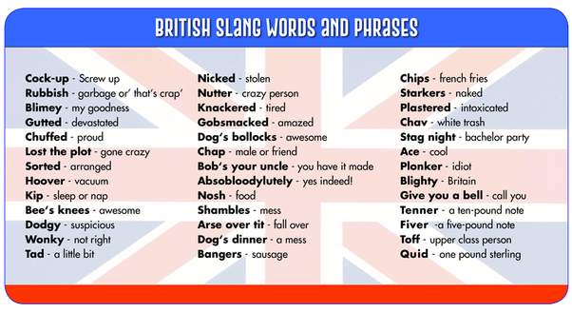

**SPEAKING PRACTICE**

Do you watch movies in English?   
Do you listen to English songs?   
Do you find them useful when learning the language? Do you think they improve your learning?   
Do you pay attention to slang words & expressions? Do know some others?

* Let’s play kahoot

<https://create.kahoot.it/details/8fd7d352-3434-4d95-ab5d-7fa033e1814b>

1. VALUES

**LISTENING ACTIVITY**

<https://www.youtube.com/watch?time_continue=51&v=bnxLIs6H3qk&feature=emb_title>

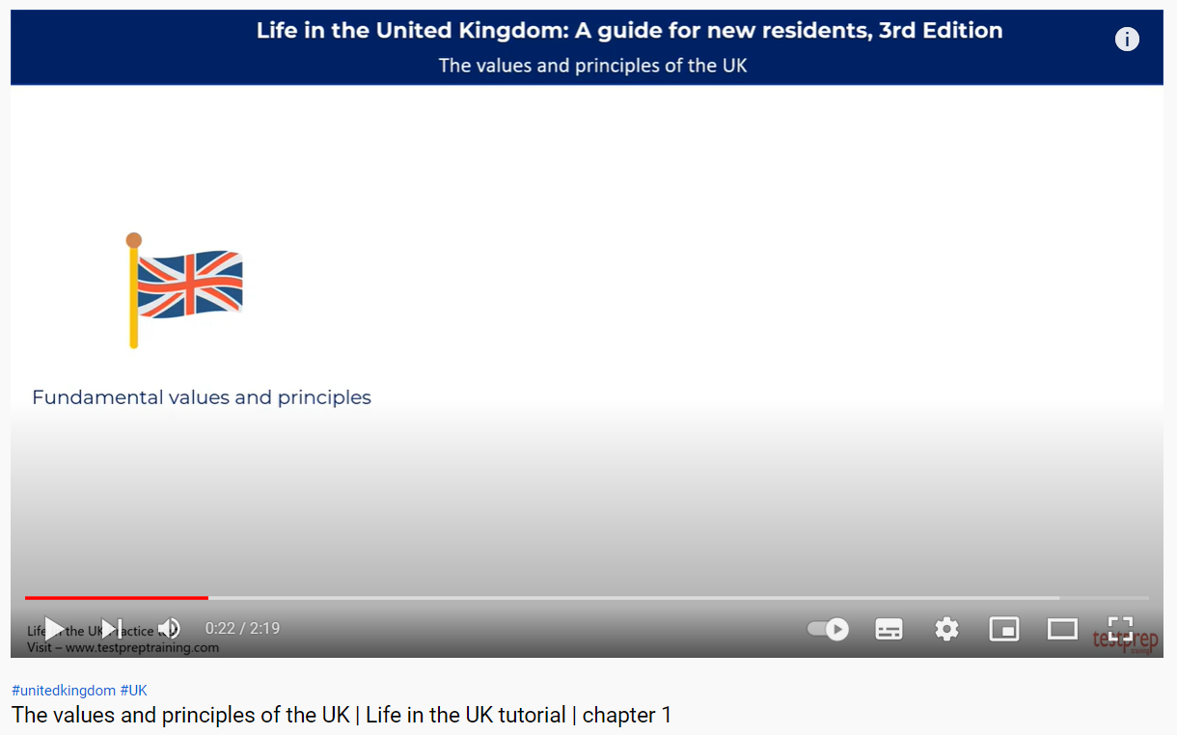

1. Fill In the gaps

British society is __founded on _______________:

1. Values & principles based on
2. history & traditions & are protected by law
3. ___customss and expectations________________________
4. What are the fundamental principles of British life?
5. Democratie
6. The ruels of law
7. Individual liberty
8. Faiyh and beliefs
9. Community life
10. Name 4 values that you should apply:
11. respect
12. Respect the rights of other
13. Treat other with fairness
14. Look after yourself and family
16. In return, the UK offers:
17. Freedom of belief
18. Freedom of speech
19. Freedom from unfair discrimination
20. A right to a fair trial
21. A right to join the election
22. BELIEFS

**SPEAKING PRACTICE**

What are the celebrations that you know related to British culture?   
What are other common beliefs in the UK?   
Do you remember some superstitions we have already talked about?

Match the dates with the corresponding celebration day and their meaning:

|  |  |  |  |  |
| --- | --- | --- | --- | --- |
| 1. 17th March |  | 1. St Andrew’s Day |  | 1. Cultural and religious celebration, the traditional death date of the foremost [patron saint](https://en.wikipedia.org/wiki/Patron_saint) of [Ireland](https://en.wikipedia.org/wiki/Ireland) (c. 385 – c. 461). |
| 1. 1st April |  | 1. Easter Monday |  | 1. Christian [holiday](https://en.wikipedia.org/wiki/Holiday) commemorating the [crucifixion of Jesus](https://en.wikipedia.org/wiki/Crucifixion_of_Jesus) and his death at [Calvary](https://en.wikipedia.org/wiki/Calvary). |
| 1. 26th December |  | 1. Good Friday |  | 1. Public holiday in many countries, part of the Easter period. Christian observance the day after [Easter Sunday](https://www.timeanddate.com/holidays/common/easter-sunday). |
| 1. 30th November |  | 1. Boxing Day |  | 1. Annual custom consisting of practical jokes and hoaxes |
| 1. 25th December |  | 1. St Patrick’s Day |  | 1. The first day of the year on the modern [Gregorian calendar](https://en.wikipedia.org/wiki/Gregorian_calendar) as well as the [Julian calendar](https://en.wikipedia.org/wiki/Julian_calendar) |
| 1. no fixed date |  | 1. Christmas Day |  | 1. [Scotland](https://en.wikipedia.org/wiki/Scotland)'s official [national day](https://en.wikipedia.org/wiki/National_day). |
| 1. no fixed date |  | 1. Remembrance Day |  | 1. Memorial day observed in [Commonwealth](https://en.wikipedia.org/wiki/Commonwealth_of_Nations) member states since the end of the [First World War](https://en.wikipedia.org/wiki/First_World_War) to remember the members of their armed forces who have died in the line of duty. |
| 1. 11th November |  | 1. New Year’s Day |  | 1. holiday celebrated the day after [Christmas Day](https://en.wikipedia.org/wiki/Christmas_Day), thus being the [second day](https://en.wikipedia.org/wiki/Twelve_Days_of_Christmas) of [Christmastide](https://en.wikipedia.org/wiki/Christmastide) |
| 1. 1st January |  | 1. April Fools’ Day |  | 1. annual festival commemorating [the birth](https://en.wikipedia.org/wiki/Nativity_of_Jesus) of [Jesus Christ](https://en.wikipedia.org/wiki/Jesus_Christ) |

**SPEAKING PRACTICE**

According to you, what is the top 6 of religions?

Atheism - Islam - Anglican Christianity – Roman Catholic Christianity –   
other forms of Christianity – Eastern religions & Judaism & other beliefs

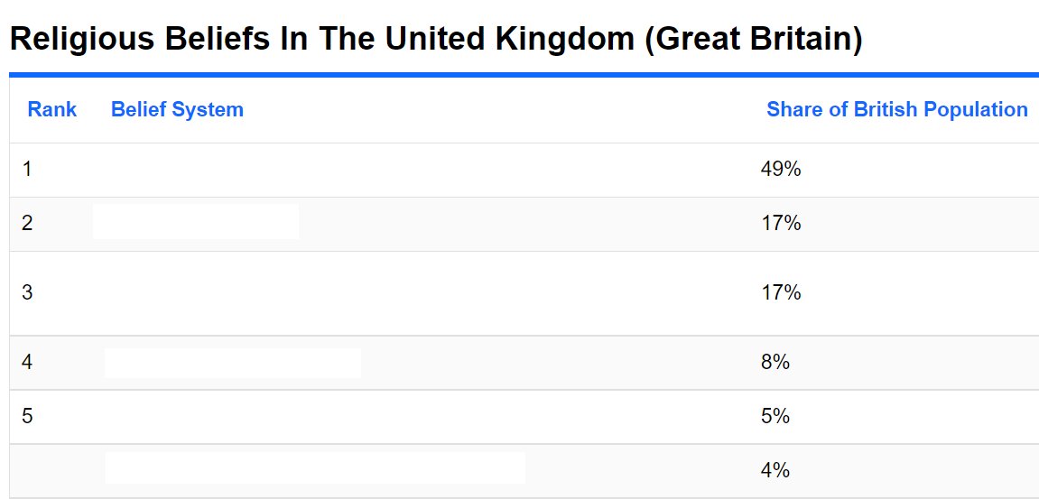

**LISTENING ACTIVITY**

<https://www.youtube.com/watch?time_continue=81&v=nxe946HZ5E4&feature=emb_title>

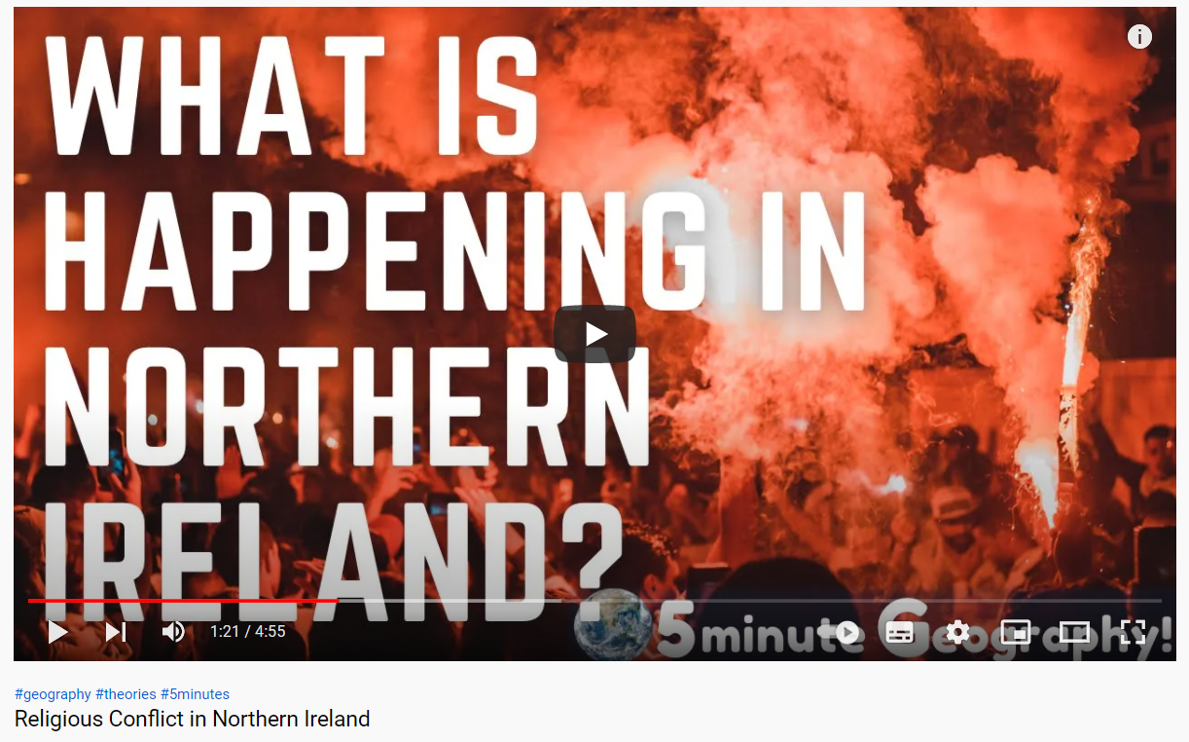

1. NORMS

**READING ACTVITY**

THINGS YOU NEED TO KNOW ABOUT THE BRITISH PEOPLE

* The British are punctual.

Being late is ____________________ (particulier, curieux) and, in some cases, considered to be rude. If you’re going to be late to something, contact those involved as soon as you know you will be late. Also, it is less rude to be late to a dinner party at someone’s home than it is to be late to a public meeting (such as dinner at a restaurant).

* Never jump lines, known as “______________” in UK.

In some countries jumping the ______________may be acceptable, but in UK, people may not be very happy with you and will definitely let you know how unhappy they are about the situation. Standing patiently in the ____________ is a normal part of British culture.

* In the UK, it’s acceptable to keep one arm’s length between yourself and those you are speaking with.

Any closer is __________________ (suppose) be aggressive and can be uncomfortable for those native to UK.

* Please, thank you, and sorry are normal parts of everyday conversations and interactions.

Some people are simply _______________(déroutés) by how polite British people are. As an international student, you may not be used to this, but you will probably get used to it quickly after your arrival!

* When _________________ (saluer) a good friend or family member in UK, you do not simply shake their hand.

Many times, especially if one of the people that are __________________ (saluer) or being ________________ (salué) is female, you will frequently give and/or receive a small kiss on the ______________ (joue). If you are not a close friend or family member, then the physical touch is perceived as _______________ (particulier, curieux) or uncomfortable (you may shake hands, but often a smile and a bow of the head is acceptable enough).

* The British have a high amount of respect for older adults and the ______________ (handicapés).

If you are on public transportation, you are expected to give up your seat if someone who is _________________ (handicapé) or older comes onto the tram (or whatever vehicle you are in) and there is no other seat. If an older adult or someone who is _____________ (handicapé) seems to be struggling with something, you are also expected to ask the person if they need your ________________________ (aide).

* British people rarely use superlatives and are not very animated when they speak.

They value privacy over everything else, so be careful what you ask because you could be _______________(être indiscret) without meaning to.

* British people often avoid extended ________________________ (contact visuel).

They find it uncomfortable and intimidating.

* If you are invited to the home of a native British person, it is normal to bring along a __________(present), such as chocolate, wine, or flowers to say thank you.
* If you go to a pub with your friends, it is common practice to buy _______________ (une tournée) of drinks for those who you came with.
* The person who has invited you to dinner is typically the one who pays.

Do not argue about whose responsibility it is, rather, invite them out to dinner at some point and pay for them to _____________________ (rendre la pareille).

* These little cultural differences will be a regular part of adapting to life in UK, and so it’s important to learn them before you even arrive.

You want to make sure that you don’t _______________________ (offenser) anyone as you’re getting used to life in UK.

If you don’t do these things naturally, the British will definitely know that you’re from out of town. This knowledge will help you get better adjusted to British norms before you start enjoying the rest of student life while attending university in UK.

1. ARTEFACTS

**FOOD**

**SPEAKING PRACTICE**

* What do you know about British food?   
  - What is the most common plate?

**READING ACTIVITY**

https://flavorverse.com/traditional-british-foods/

Match each name with the picture and then, match it with its explanation.

a. 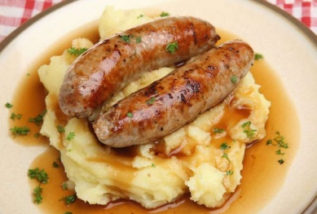b. 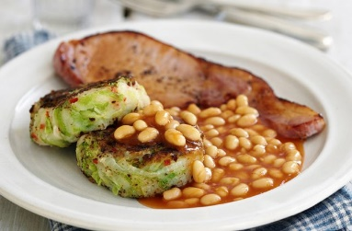 c. 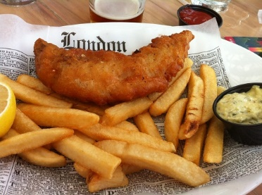

d. 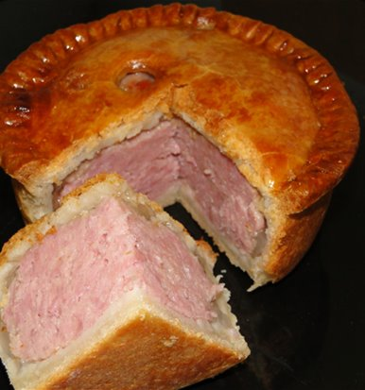 e. 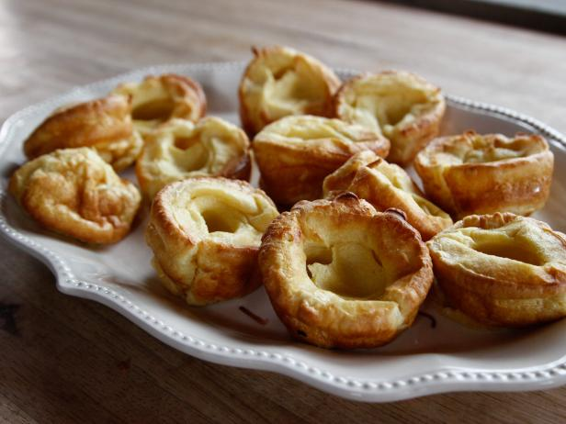 f. 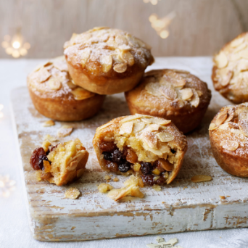

g. 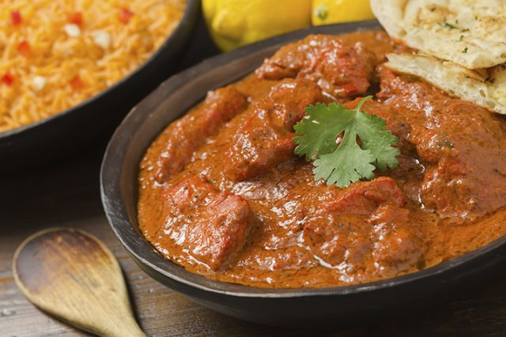 h. 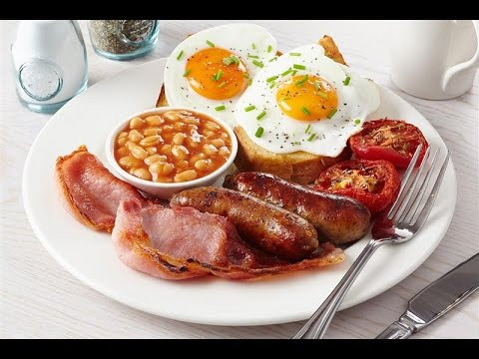 i. 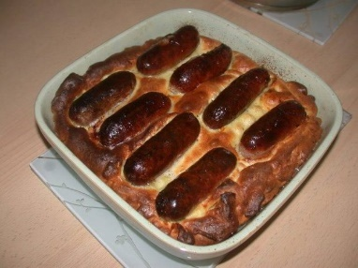

1. **Toad in the Hole** (Britain’s Staple Dinner Food) : ……..
2. **Full English Breakfast** (Famous and Typical British Platter) : ……..
3. **Chicken Tikka Masala** (Famous British Indian Cuisine) : ……..
4. **Pork Pies** (Classic British Food in Buffets) : ……..
5. **Yorkshire Pudding** (Britain’s National Dish) : ……..
6. **Mince Pie** (Popular Christmas Dessert of Britain) : ……..
7. **Bangers and Mash** (Traditional English Sausage Dish for Lunch) : ……..
8. **Bubble and Squeak** (Popular British Breakfast Food) : ……..
9. **Fish and Chips** (Traditional British Food) : ……..

**1. ……………………………..:** It earns its name because of the squeaking and bubbling sound made by the cabbage (its primary ingredient) when cooked. Potatoes, carrots, Brussels sprouts, and peas are also a part of this dish, mostly prepared from leftover veggies of a previous day’s meal. It is served with cold meat or eaten as a side dish in an English breakfast platter.

**2. ………………………………:**  Sausage made from lamb, beef, or pork, combined with mashed potatoes, makes this delicious dish. The term banger is said to date back to the time of the First World War when sausages needed so much water that they would pop when cooked at an increased temperature.

**3. ………………………………:** A popular Christmas dish, it originated as early as the 13th century. Dried fruits, cloves, cinnamon, and nutmeg go into its preparation at present instead of meat.

**4. ………………………………:** it derives its name from its place of origination, also regarded as England’s national dish for a long time. Its preparation comprises of a batter of flour and eggs alongside milk or water. It can be eaten as a side dish or served in the main course with beef and other delicacies.

**5. ………………………………:** A lip-smacking cold meat pie made from pork and its jelly. This dish also has carrots, celery, peppercorn, onion, and even the pig’s trotter as its main ingredients.  Though mostly eaten cold, some parts of Britain serve it warm along with peas and mint dip.

**6. ………………………………:** A spicy, baked dish prepared from chunks of chicken marinated with an array of spices, yogurt, and tomato or coriander sauce. Though this dish is known to have its roots in the Indian state, Punjab, there are claims of its origination to be in Scotland’s Glasgow, at a restaurant managed by Indians. Robin Cook, a member of the parliament, termed it as Britain’s national dish in 2001ranking it as the second most famous foreign dish served in Britain.

**7. ………………………………:** attained popularity in Ireland and Britain since the Victorian period. It comprises not just a particular food but a complete platter of bacon, eggs, sausage, mushroom, baked beans, tomatoes, and bread alongside tea and coffee.

**8. ………………………………:** Sausages, made in a batter of the Yorkshire pudding, served with vegetables and gravy. The story behind this unusual name remains ambiguous; it might be called so because of its presentation, which seems as if the sausages are making their way through the gaps present in the batter.

**9.** **………………………………:** One of the most staple foods of Britain, it originated as early as the 19th century. Deep-fried battered fish, served along with crispy potato chips, is all that this platter is about. This lip-smacking savoury has become a significant takeaway snack not only in Britain but also in New Zealand and Australia.

**SPORTS**

**SPEAKING PRACTICE**

* According to you, what are the most practised sports in the UK?
* Which have British origins?
* Which best represents the British culture? Why?
* Do you know weird sports that are only practised in the UK?
* Which sport do you think is the silliest?
* Which do you think is the most difficult?
* Which sport would you like to try?

**READING ACTIVITY**

https://www.teachingenglish.org.uk/article/sporting-traditions

Read these descriptions of sporting customs in the UK and answer the questions.

**Sporting traditions in the UK**

Forty-one days before Easter Sunday is a special day for Christians. All over England people used to celebrate the start of this period before Easter known as Lent by using up all their milk, flour and eggs. They made pancakes with the ingredients and then held pancake races in the streets. Each town has its own rules for the pancake races. The oldest and most famous is held in Olney in Buckinghamshire. The players must be women over the age of 16 and they wear a hat and an apron. They must run for nearly 400 metres with a frying pan with a pancake in it. They must throw the pancake in the air (toss it) at least 3 times during the race. The first woman to the finish line with a pancake in her pan is the winner. It is a great skill to toss a pancake and run at the same time.

The Highland Games is a Championship which began in the middle of the 19th century in the Scottish Highlands. Games are traditionally held in September. One of the most popular sports is 'tossing the caber'. Tossing means throwing. Players have to throw a long and extremely heavy wooden pole, like a tree trunk. The average caber weighs 68 kilos and is usually about 6 metres long. The heaviest caber in the history of caber tossing weighed an incredible 127 kilos. The player who throws his wooden caber the furthest is not necessarily the winner. The style of throwing is more important than the distance. Players are usually very big and strong!

St John's Ambulance and first aid volunteers are always present at the two day football match held in Ashbourne[1] in the Midlands every Spring. The Ashbourne street football game is one of many street football matches played out all over the UK. The town is divided into two teams, depending on where you live. There can be hundreds of players in each team and the two goal posts are nearly five kilometres apart. The ball is not kicked but Une image contenant personne, foule, grand, extérieur
'hugged' close to the chest. The shopkeepers in the centre of town have to cover their windows with wooden boards to stop the crowds of players smashing in to the glass. All locals, young and old, enjoy this very lively and sometimes violent game. The match ends with a few broken arms or injuries but it is all so much fun say the locals. They have been playing this game every year for more than two centuries. It is a bit difficult to get the ball from one end of town to the other and this year they played until 10 in the evening. Unfortunately, nobody was able to score a goal.

1. Which sport is practised throughout the UK?
2. Which sport is not usually played by men?

1. Which sport has an incredible number of players?

1. Which sport is the most dangerous? Explain why.
2. Which sport requires the most physical strength? Explain why.
3. Which sports involve throwing something?

**LITERATURE**

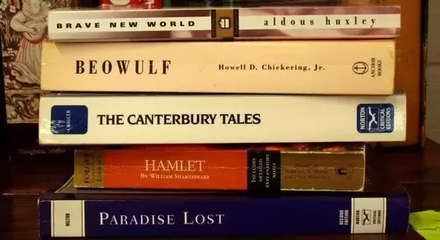

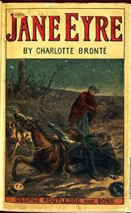 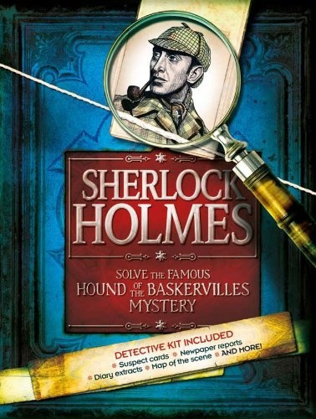 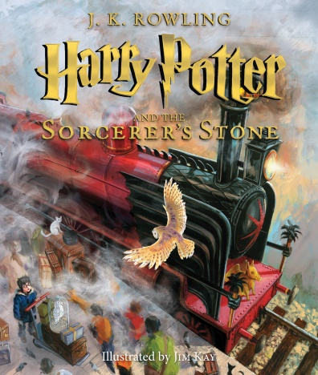

Give useful details about each book

**MUSIC**

Try to discover the name of each singer/band. Give one of their most famous songs.

 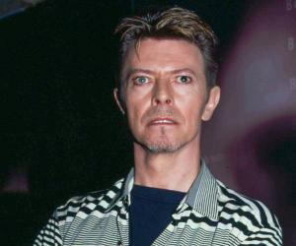 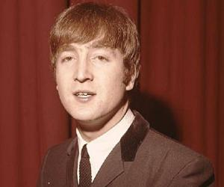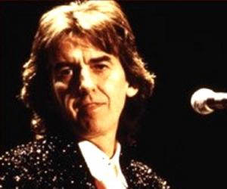  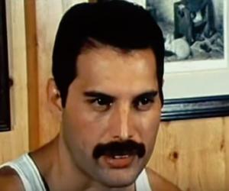      

Explain each image. Why are they artefacts of the British culture? What do they symbolise?

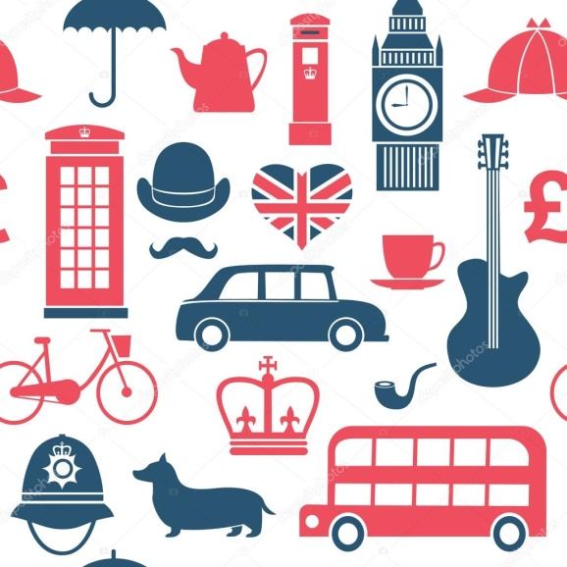 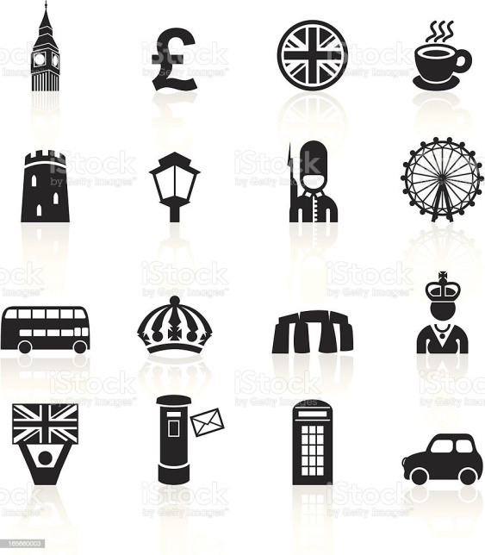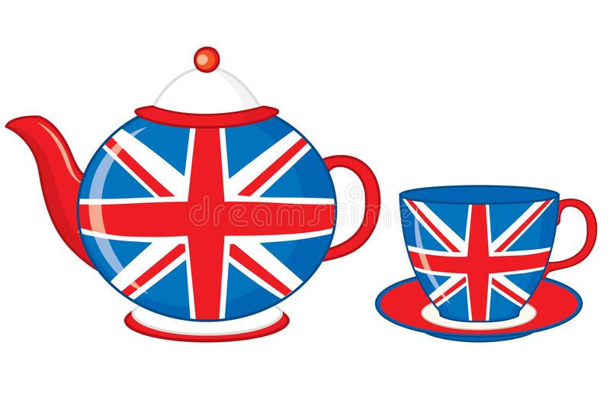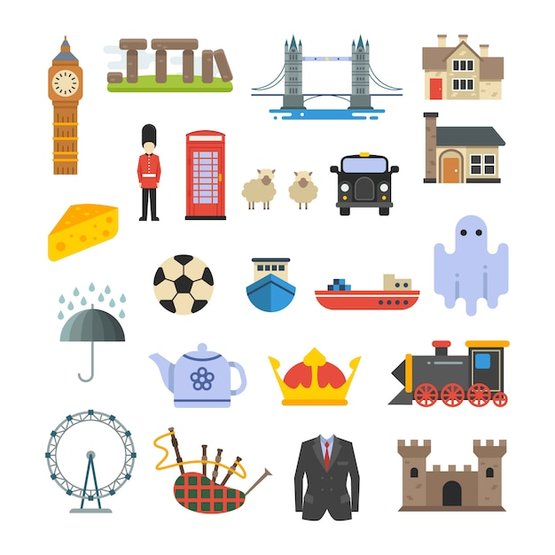 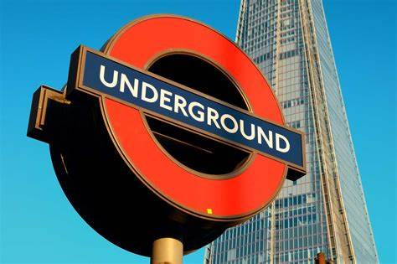 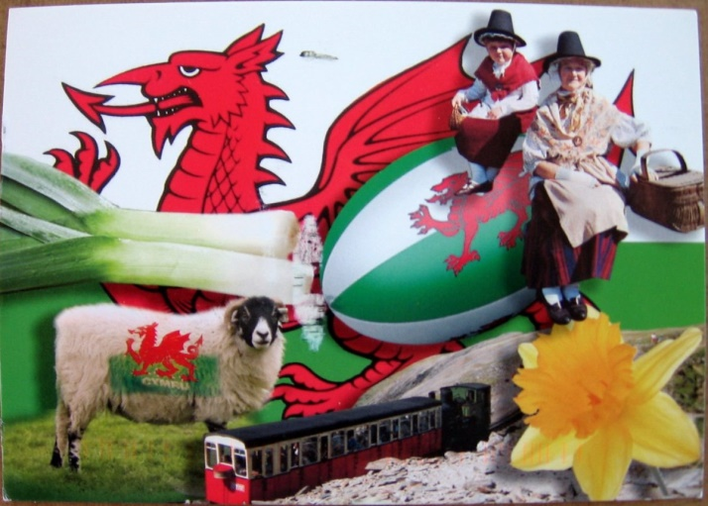

1. link to Ashbourne street football: [https://www.youtube.com/watch?v=y48Uq6Nisf8&ab_channel=BritishPath%C3%A9](https://www.youtube.com/watch?v=y48Uq6Nisf8&ab_channel=BritishPath%25C3%25A9)